SAVEETHA SCHOOL OF ENGINEERING
SAVEETHA INSTITUTE OF MEDICAL AND TECHNICAL SCIENCES
COMPUTER SCIENCE AND ENGINEERING PROGRAMME
CSA04 – OPERATING SYSTEMS
Name: DHARANI KARTHICK
Reg no: 192521082

LIST OF PROGRAMS
11. Illustrate the concept of multithreading using a C program.
/* Multithreading demo (Windows) */
#include <stdio.h>
#include <windows.h>

#define NUM_THREADS 4
#define LOOP_COUNT 500000

volatile long long unsafe_counter = 0; /* no protection -> race condition */
volatile long long safe_counter = 0; /* protected by critical section */
CRITICAL_SECTION cs;

DWORD WINAPI worker(LPVOID param) {
int id = (int)(INT_PTR)param;
printf("[Thread %d] Started (Thread ID %lu)\n", id, GetCurrentThreadId());

for (int i = 0; i < LOOP_COUNT; i++) {
unsafe_counter++; /* many threads write at once: data race */

EnterCriticalSection(&cs); /* only one thread at a time in here */
safe_counter++;
LeaveCriticalSection(&cs);
}

printf("[Thread %d] Finished (Thread ID %lu)\n", id, GetCurrentThreadId());
return 0;
}

int main(void) {
HANDLE threads[NUM_THREADS];
InitializeCriticalSection(&cs);

printf("Main thread (ID %lu) creating %d threads...\n\n",
GetCurrentThreadId(), NUM_THREADS);

for (int i = 0; i < NUM_THREADS; i++) {
threads[i] = CreateThread(NULL, 0, worker, (LPVOID)(INT_PTR)(i + 1), 0, NULL);
if (threads[i] == NULL) {
printf("CreateThread failed (%lu)\n", GetLastError());
return 1;
}
}

/* Wait for all threads to finish (join) */
WaitForMultipleObjects(NUM_THREADS, threads, TRUE, INFINITE);

for (int i = 0; i < NUM_THREADS; i++)
CloseHandle(threads[i]);
DeleteCriticalSection(&cs);

long long expected = (long long)NUM_THREADS * LOOP_COUNT;
printf("\nExpected value : %lld\n", expected);
printf("Without synchronization: %lld %s\n", unsafe_counter,
unsafe_counter == expected ? "(lucky run)" : "(WRONG - race condition)");
printf("With critical section : %lld %s\n", safe_counter,
safe_counter == expected ? "(correct)" : "(wrong)");
return 0;
} 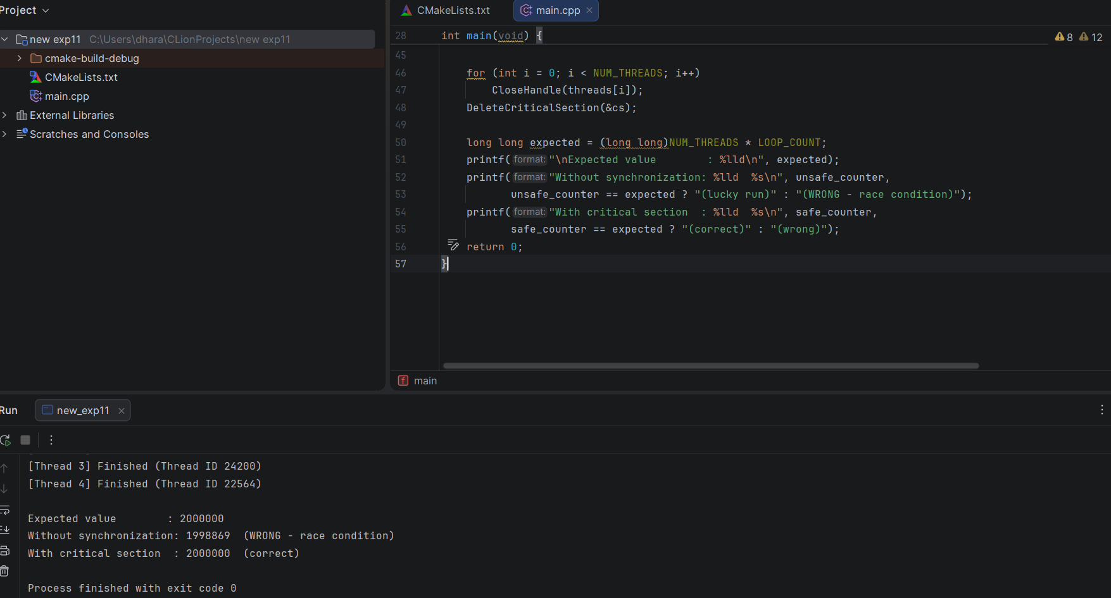

12. Design a C program to simulate the concept of Dining-Philosophers problem
/* Dining Philosophers simulation (Windows) */
#include <stdio.h>
#include <windows.h>

#define N 5 /* number of philosophers / chopsticks */
#define ROUNDS 3 /* how many times each philosopher eats */

HANDLE chopstick[N]; /* one mutex per chopstick */

DWORD WINAPI philosopher(LPVOID param) {
int id = (int)(INT_PTR)param;
int left = id;
int right = (id + 1) % N;

/* Resource ordering: always take the lower-numbered chopstick first */
int first = left < right ? left : right;
int second = left < right ? right : left;

for (int round = 1; round <= ROUNDS; round++) {
printf("Philosopher %d is THINKING (round %d)\n", id, round);
Sleep(200 + id * 80);

printf("Philosopher %d is HUNGRY\n", id);
WaitForSingleObject(chopstick[first], INFINITE);
WaitForSingleObject(chopstick[second], INFINITE);

printf("Philosopher %d is EATING (chopsticks %d and %d)\n",
id, left, right);
Sleep(300);

ReleaseMutex(chopstick[second]);
ReleaseMutex(chopstick[first]);
printf("Philosopher %d put down chopsticks %d and %d\n", id, left, right);
}

printf("Philosopher %d has FINISHED all meals\n", id);
return 0;
}

int main(void) {
HANDLE threads[N];

for (int i = 0; i < N; i++)
chopstick[i] = CreateMutex(NULL, FALSE, NULL);

printf("Dining Philosophers: %d philosophers, %d meals each\n\n", N, ROUNDS);

for (int i = 0; i < N; i++)
threads[i] = CreateThread(NULL, 0, philosopher, (LPVOID)(INT_PTR)i, 0, NULL);

WaitForMultipleObjects(N, threads, TRUE, INFINITE);

for (int i = 0; i < N; i++) {
CloseHandle(threads[i]);
CloseHandle(chopstick[i]);
}

printf("\nAll philosophers have finished eating. No deadlock occurred.\n");
return 0;
} 